CV ASSIGNMENT – 3

2.

(i)We are using the pretrained AlexNet. The classifier[6] is changed to 8 to get 8

out_features which was asked to implement.



(ii)Read the csv files of train and test and create dictionary with image and corresponding labels for it*.*

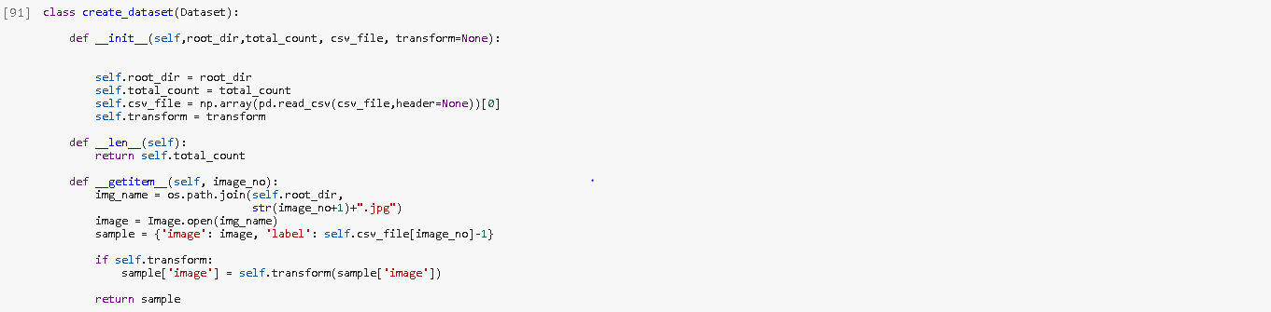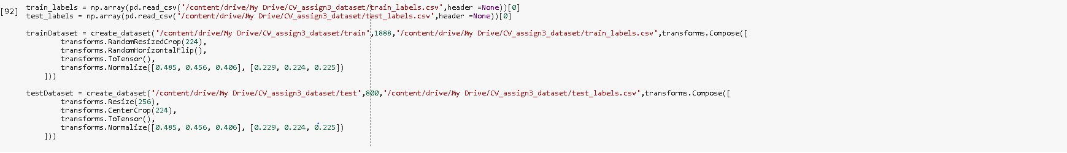

(iii)Initialize the model using initialize_model function where you load the pretrained model of alexnet.

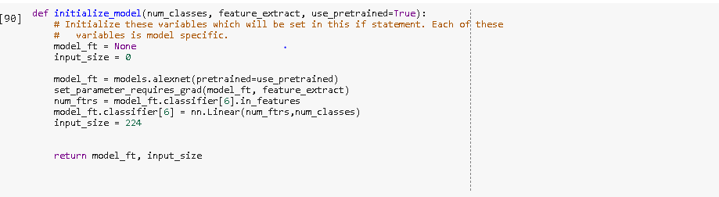

(iv) We will get the parameters to be optimized or updated. Here we will know what parameters to be learned.

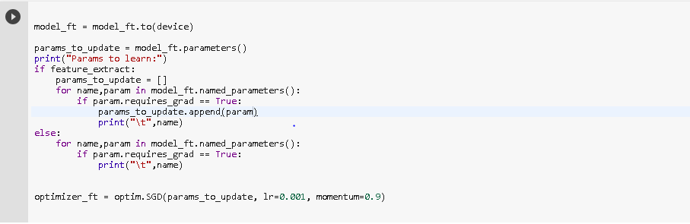

(v) Training the model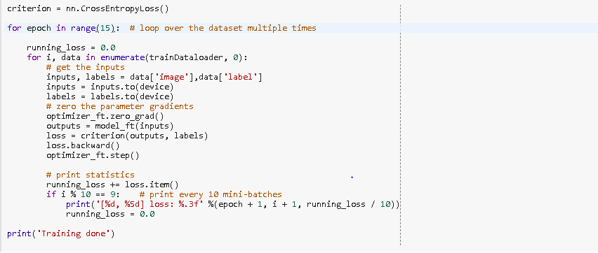

(vi)Testing the model

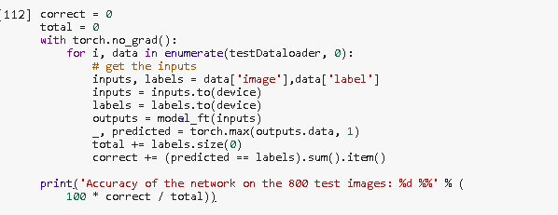

Accuracy:

